**XML –**

Extensible Markup Language (**XML**) is a markup language that defines a set of rules for encoding documents in a format that is both human-readable and machine-readable. The World Wide Web Consortium's **XML** 1.0 Specification of 1998 and several other related specifications—all of them free open standards—define **XML**.

* XML stands for eXtensible Markup Language
* XML is a markup language much like HTML
* XML was designed to store and transport data
* XML was designed to be self-descriptive
* XML is a W3C Recommendation

The Difference Between XML and HTML

XML and HTML were designed with different goals:

* XML was designed to carry data - with focus on what data is
* HTML was designed to display data - with focus on how data looks
* XML tags are not predefined like HTML tags are

**Tag rules**

1) Every tag should have a closing tag

2) It is case sensitive

3) There should be one root tag

4) Attribute value should be in single or double quotes

Example –

Employee is a root tag and id , name is other tags

<?xml version=*"1.0"* encoding=*"UTF-8"*?>

<!-- this is comment -->

<employee>

<id>1001</id>

<name>Jyoti</name>

</employee>

Output-

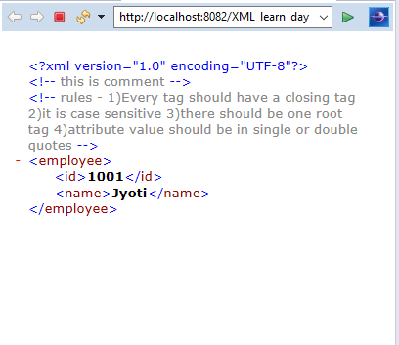

Grammar –

1. Structure – by using DTD we an define the structure .
2. Content – to make content valid ex- giving data 🡪we can use schema

Xml file –

<?xml version=*"1.0"* encoding=*"UTF-8"*?>

<!DOCTYPE employees SYSTEM "Employee.dtd">

<employees>

<employee>

<id>1001</id>

<name>Jyoti</name>

</employee>

<employee>

<id>1002</id>

<name>Shreyansh</name>

</employee>

<employee>

<id>1003</id>

</employee>

</employees>

Create DTD file

Employee.dtd 🡪

<!DOCTYPE employees

[

<!ELEMENT employees (employee+)>

<!ELEMENT employee (id,name)>

<!ELEMENT id (#PCDATA)>

<!ELEMENT name (#PCDATA)>

]>



